Amanda Tirey Module 4.2 Take 1
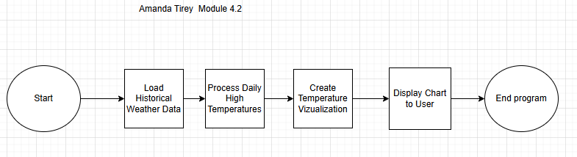
Amanda Tirey Module 4.2 Take 2 Revised Flowchart
